
Aston on Trent Primary School
Knowledge Organiser
Curriculum overview
Throughout this unit, we will explore what it means to be physically and mentally healthy and what might influence our choices. We will also recognise positive and negative lifestyle habits including mouth hygiene, physical activities and sleep routines.
Key vocabulary |  | Sticky knowledge
 | Our topic is…  Being Healthy  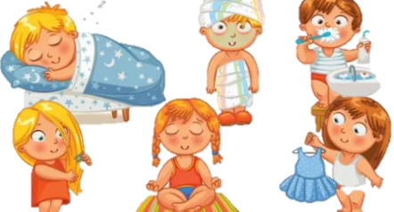 | Different things affect your physical and mental health.  A balanced diet is made up of food groups (fruit and vegetables, protein, carbohydrates, diary, oils and fats).  Physical activity is very important to keep our body healthy.  Mouth hygiene is important to stop the spread of infections.  Bedtime routines can help us get goodnights sleep regularly.
  Mental Health | This is the way people think, feel and act.
  Physical Health | A healthy body.
  Hygiene | The practice of keeping clean to stay healthy and prevent disease.
  Lifestyle | The way you live.
  Routines | A usual order and way of doing something.
  Balanced | Balance is having the right amount- not too much or too little
  Healthy | Being well and free of sickness.
Texts and Links |  | Tips for Mental health
Dr Binocs: Dr Binocs: The Busy Body Book  What if we stop Why do we sleep? By Lizzy Rockwell  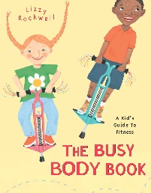    brushing teeth?    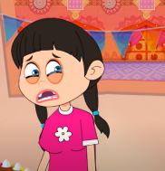    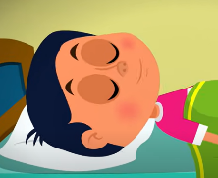 |  | 

