
Aston on Trent Primary School
Knowledge Organiser
Curriculum overview
Throughout this unit, we will explore both positive and negative friendships, identify positive strategies to help us resolve friendship fallouts and recognise how negative behaviour can make other people feel. We will also discuss what discrimination means and suggest what strategies to respond to hurtful behaviour.
Key vocabulary |  | Sticky knowledge
 | Our topic is…  Bullying Matters  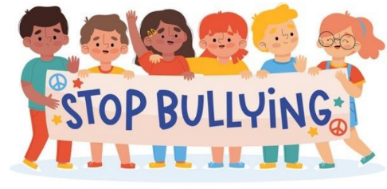 | Positive strategies can be used to help resolve disagreements in friendships.  If a friendship (online or offline) is making someone feel unsafe or uncomfortable, they must tell a trusted adult.  Discrimination is when you treat a person or group of people unfairly and differently to others.  Behaviour someone displays can affect others.  Bullying is behaviour which is repeated on purpose and is meant to upset someone.
  Discrimination | Treating a person or group of people unfairly and differently to other people.
  Consequences | Something which happens because of an event or action. This can be positive or negative.
  Behaviour | The way you behave and treat one another.
  Appropriate | Normal, safe and acceptable behaviour in a situation.
  Inappropriate | Abnormal, unsafe and unacceptable behaviour in a situation.
  Cyber- bullying | Bullying that takes place on electronic devices like phones, computers and tablets.
  Bullying | Repeated unkind behaviour, such as being mean to others on purpose.
Texts and Links |  | What is Bullying?
Anti-Bullying Leaflet Marshall Armstrong is  Aston-on-Trent New to Our School  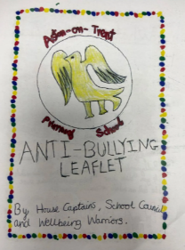  David Mackintosh       |  | It is important to remember that single problems and falling out with friends are not bullying.  